**EXPERIMENT – 7**

**TITLE: Exceptions**

1. **Write a program in Java to display the names and roll numbers of students. Initialize respective array variables for 10 students. Handle ArrayIndexOutOfBoundsExeption, so that any such problem doesn’t cause illegal termination of program.**

import java.util.Scanner;

class test{

public static void main(String args[]){

int i;

String arr[]= new String[10];

int roll[]= new int[10];

Scanner sc= new Scanner(System.in);

try{

for(i=0;i<11;i++){

System.out.println("Enter name of student\t" + (i+1) );

arr[i]=sc.nextLine();

System.out.println("Enter rollno of student\t" + (i+1));

roll[i]=Integer.parseInt(sc.nextLine());

}}

catch (ArrayIndexOutOfBoundsException e) {

System.out.println("Array is out of Bounds"+e);}

for(i=0;i<11;i++){

System.out.println("name of student \t" + (i+1) + "\t is" );

System.out.println(arr[i]);

System.out.println("name of roll \t" + (i+1) + "\t is" );

System.out.println(roll[i]);

}

}

}

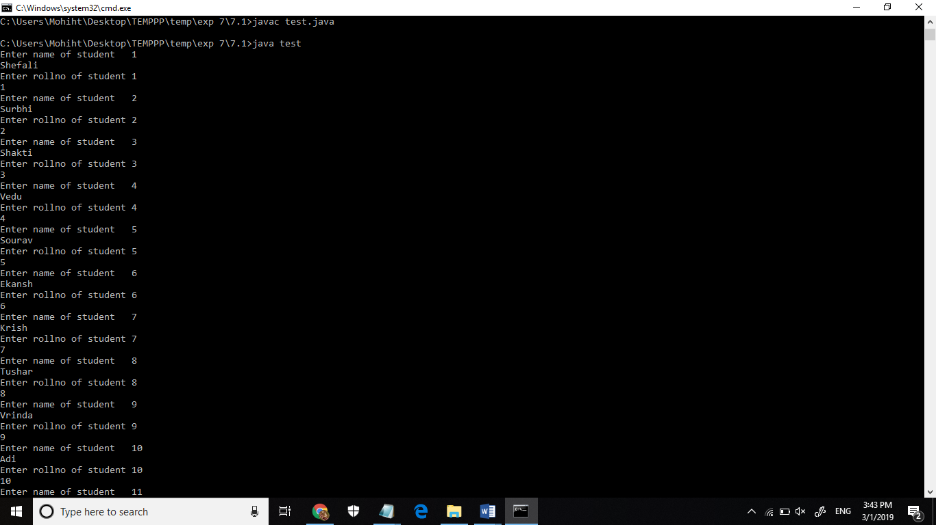

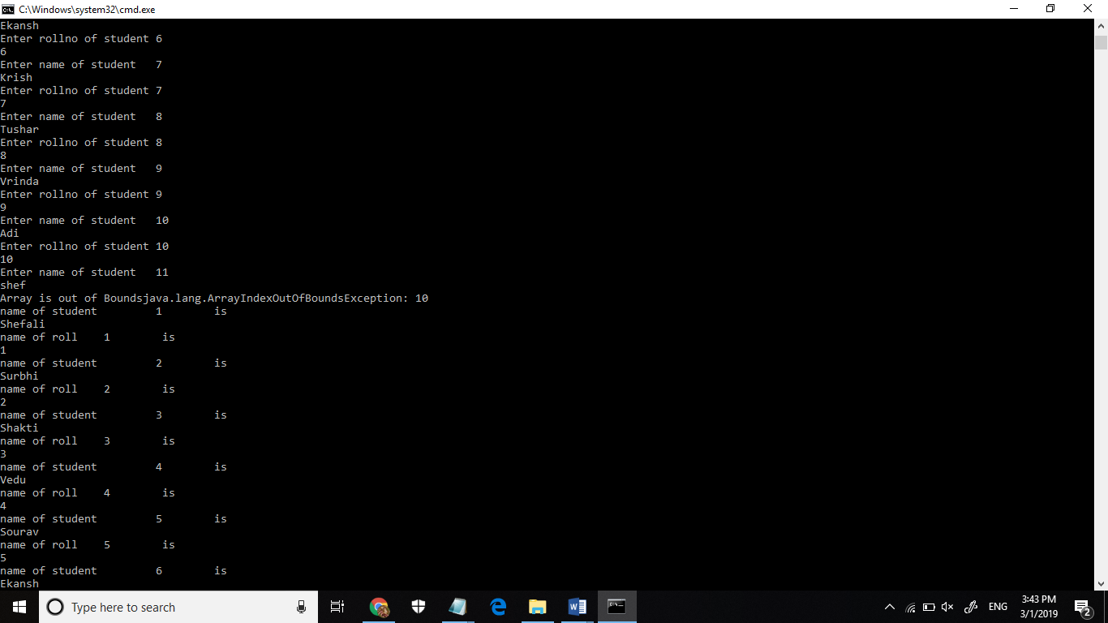

1. **Write a Java program to enable the user to handle any chance of divide by zero exception.**

import java.util.Scanner;

class dividezero{

public static void main(String args[]){

Scanner sc= new Scanner(System.in);

int a, b;

System.out.println("Enter two numbers");

a=sc.nextInt();

b=sc.nextInt();

try{int c= a/b;

System.out.println("Result is \t" + c);

}

catch(ArithmeticException e){

System.out.println("Error: Divided by Zero");

}

}

}

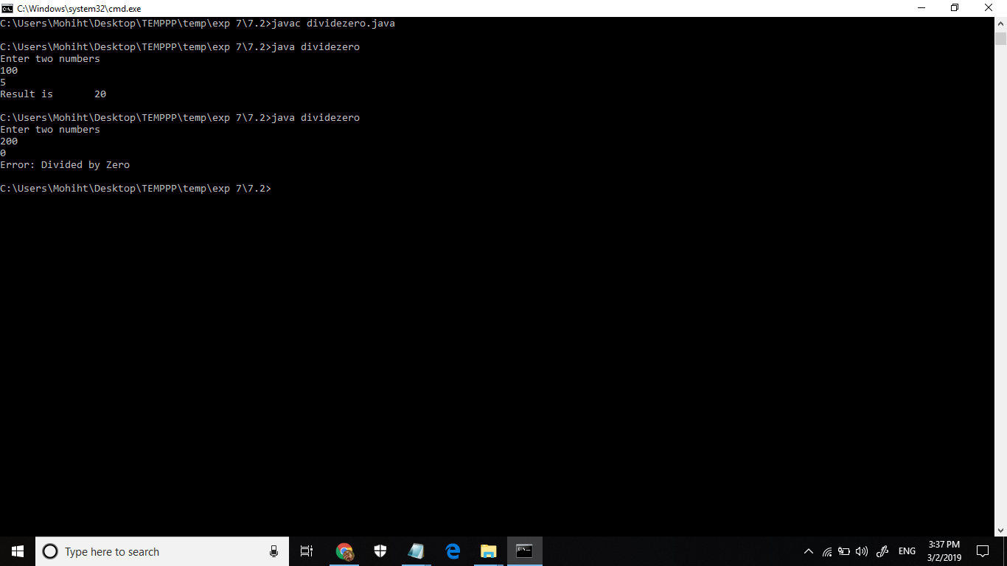

1. **Create an exception class, which throws an exception if operand is nonnumeric in calculating modules. (Use command line arguments).**

class calc

{

public static void main(String ar[])

{

int a,b,c=0;

try{

a=Integer.parseInt(ar[0]);

b=Integer.parseInt(ar[1]);

System.out.println(a);

System.out.println(b);

}

catch(NumberFormatException e)

{System.out.println(e);

}

}

}

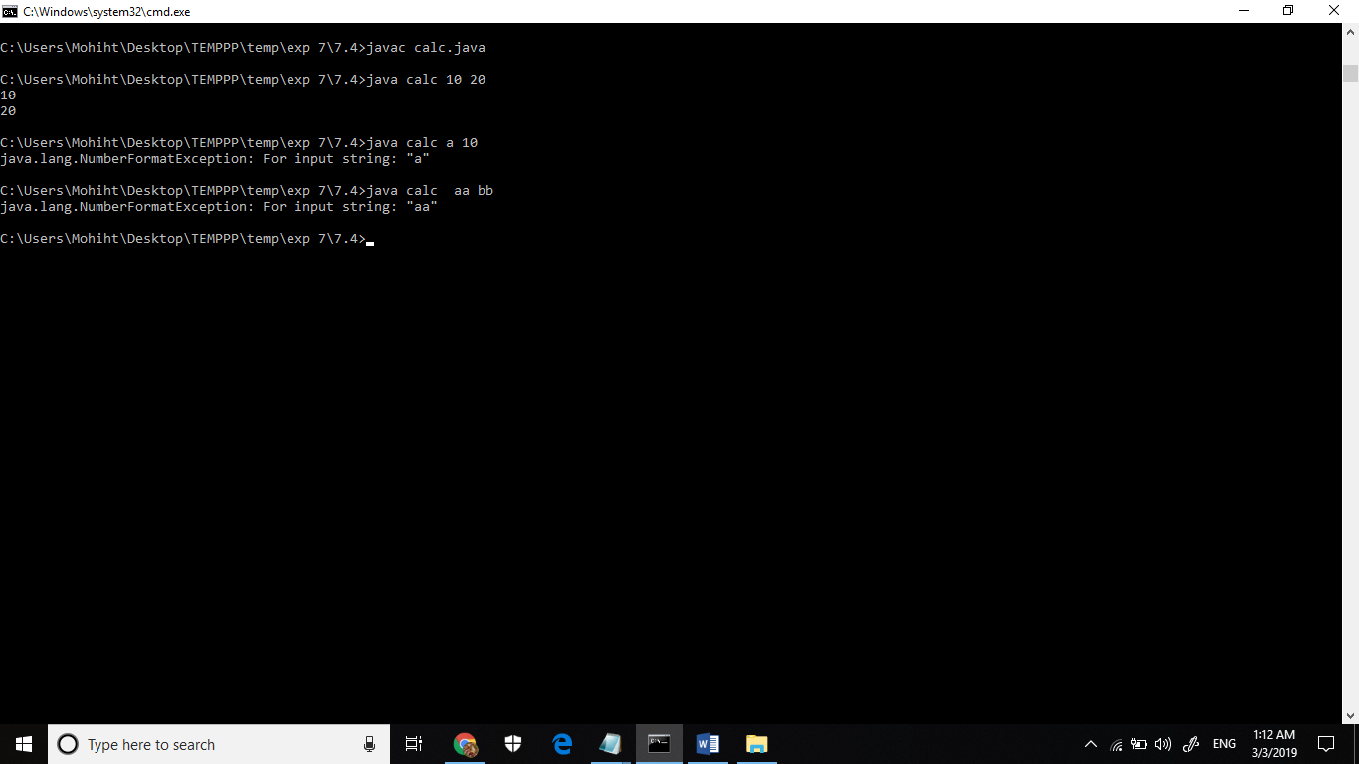

1. **On a single track two vehicles are running. As vehicles are going in same direction there is no problem. If the vehicles are running in different direction there is a chance of collision. To avoid collisions write a Java program using exception handling. You are free to make necessary assumptions.**

import java.util.Scanner;

import V1.VehicleException;

class Vehicle{

public static void main(String args[]){

System.out.println("Enter two direction for two cars Press 1 for right and 2 for left:");

Scanner sc= new Scanner(System.in);

int a, b;

a=sc.nextInt();

b=sc.nextInt();

try

{

checkVehicleException (a, b);

System.out.println ("Vehicles can pass without collision");

}

catch (VehicleException e)

{

System.out.println (e + "\n");

}

}

public static void

checkVehicleException (int a, int b)

throws VehicleException

{

if (a == b){

throw new VehicleException ("Error: Same direction. They will collide ");

}

}

}

**(Package)**

package V1 ;

public class VehicleException extends Exception{

public VehicleException (String S){

super(S);

}

}

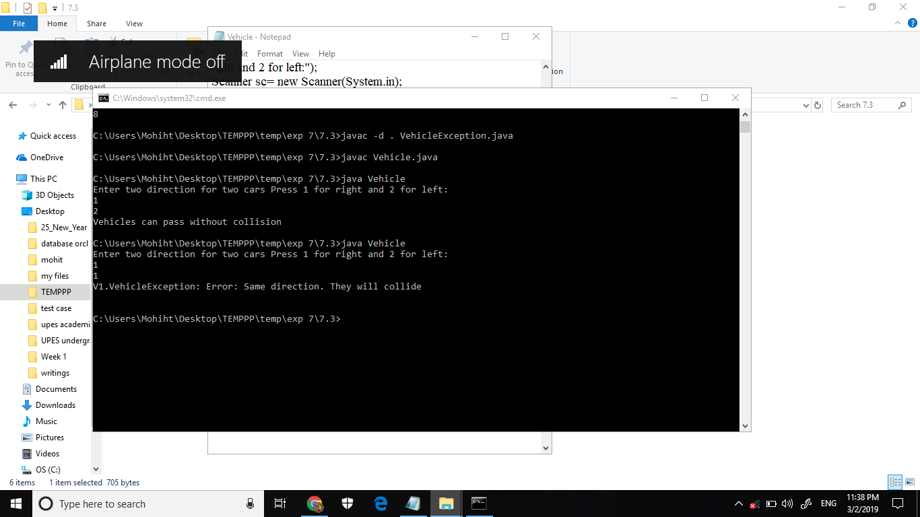

**5) Write a java program to throw an exception for an employee details.**

* **If an employee name is a number, a name exception must be thrown.**
* **If an employee age is greater than 50, an age exception must be thrown.**
* **Or else an object must be created for the entered employee details**

import java.util.Scanner;

class AgeException extends Exception{

AgeException(String s){

super(s);}

}

class nameException extends Exception{

}

class employee{

public static void main(String args[]) {

Scanner sc= new Scanner(System.in);

String emp[] = new String[10];

int age[]= new int[10];

try{

for(int i=0; i<10;i++){

System.out.println("Enter employee name");

emp[i]=sc.nextLine();

if(!(emp[i].matches("[a-zA-Z]+")))

{throw new nameException();}

System.out.println("Enter employee age");

age[i]=Integer.parseInt(sc.nextLine());

checkAgeException(age[i]);

}

}

catch(nameException e1){

System.out.println ("no int for name");

}

catch(AgeException e){

System.out.println (e + "\n");

}

}

public static void checkAgeException(int age) throws AgeException {

if(age>50){ throw new AgeException("The age is above 50");

}

}

}

